SOP Publishing a printer

Once you create and share a printer, as shown in the previous recipe, you can additionally publish it to the Active Directory. When you publish a printer, you can also specify a location for the printer that enables your users to search for published printers based on location and capabilities. End users can search AD to find printers and to find the printers near to them. In this recipe, you publish the printer you created in the previous recipe and examine the results.

How to do it:

1.Get the printer to publish and store the returned object in $Printer:

$Printer = Get-Printer -Name SGCP1   
2.Observe the publication status:

$Printer | Format-Table -Property Name, Published   
3.Publish the printer to AD:

$Printer | Set-Printer -Published $true -Location '10th floor 10E4'

4.View the updated publication status:

Get-Printer -Name SGCP1 | Format-Table -Property Name, Published, Location

How it works:

In *step 1*, you get the printer details for the Sales Group group's printer, SGCP1, and store it in $Printer. There is no output from this step.

In *step 2*, you output the printer details to see that you have not yet published the printer:

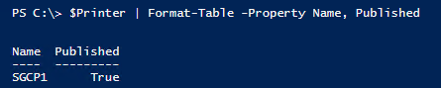

In *step 3*, you publish the printer by piping the Printer object to Set-Printer, specifying that you wish to publish the printer.

In *step 4*, you can see the results of publishing the printer:

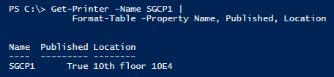

As you can see, you have now published the printer and set the location to the 10th   
floor, area 10E4.

Start | Settings | Devices | Printers & Scanners

When you publish a printer to the Active Directory, users need to be able to find it. One   
way is to use the Find Printers dialog to search for published printers.

To use this (in Windows Server 2016 and Windows 10), you click Start | Settings | Devices | Printers & scanners to bring up the Add printers & scanners dialog.

From this dialog box, click Add a printer or scanner. Wait until the searching is complete, then click on “The printer that I want isn't listed”, which brings up the Add Printer dialog:

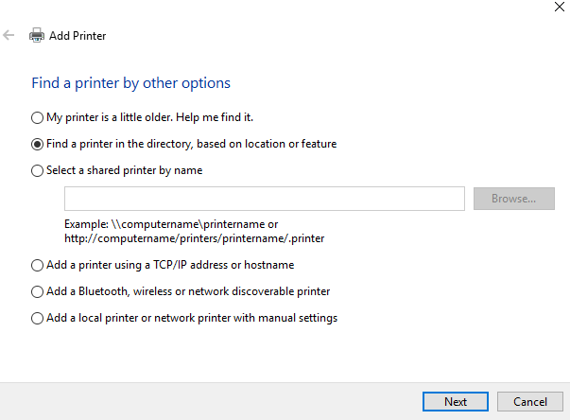

Select “Find a printer in the directory, based on location or feature”, then click Next.

You now see the Find Printers dialog:

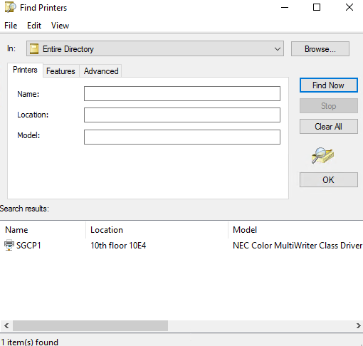

You, or your users, can use the Printers tab to search for printers by Name, Location, and   
Model, and use the Features tab to search for printers with specific features (for example,   
the ability to print in color).

rundll32.exe is another option

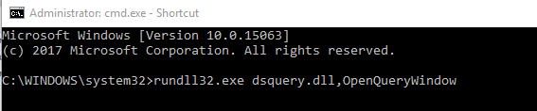

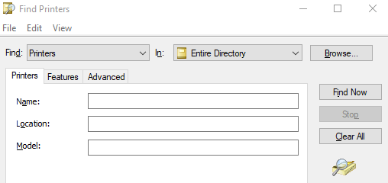

Save the Query as addprinter.qds